**DIABETES PROBLEM**

**PROBLEM STATEMENT AND ANALYSIS:**

Diabetes is a disease which causes an increase in blood sugar. Here we have a problem to classify the patients who have diabetes with the given glucose and blood pressure values. So we implement the K Nearest Neighbours classifier to give us the classified output with its accuracy. KNN algorithm is one of the simplest classification algorithms and it is one of the most used learning algorithms. The main aim is to analyse and predict whether the respective patient has diabetes or not based on several factors.

**SAMPLE DATASET:**

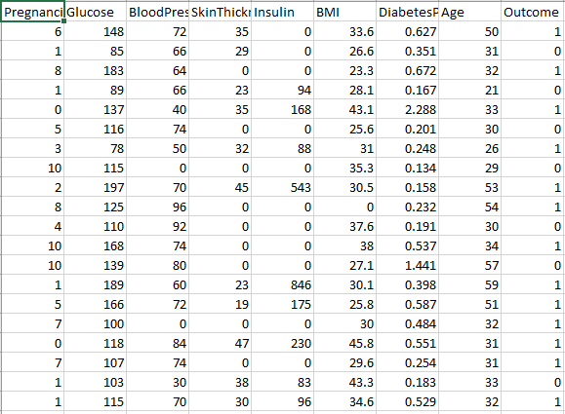

**DATASET DESCRIPTION**:

The dataset contains the real time data of the diabetic patients with the corresponding factors that indicates that the patient has diabetes. This data set contains 9 columns “Pregnancies”, “Glucose”, “Blood Pressure”, “Skin Thickness”, “Insulin”, “BMI”, “Diabetes Pedigree Function”, “Age” and “Outcome”. Containing these features the “Outcome” feature is the target variable which tells us whether the patient has diabetes or not. “0” corresponds to the decision that the patient does not have diabetes and “1” represents that the patient has diabetes.

**OUTPUT:**

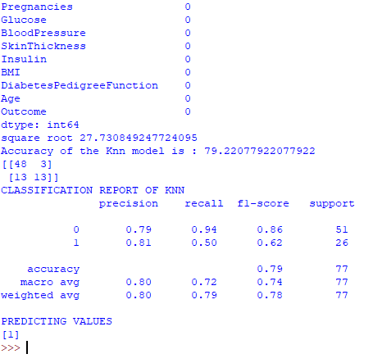

**INFERENCE:**

From the confusion matrix we can say that there are 48 true positive patients, 13 true negative patients, 3 false positive patients and 13 false negative patients.

Coming to the classification report, it displays the Precision, Recall, F1 and Support scores for the model.

 • Precision Score for class 0 (negative) is 0.79 and for class 1 (positive) is 0.81, indicating the preciseness of the model.

• Recall value for class 0 is 0.94 and class 1 is 0.50, which describes the amount upto which the model can predict the output.

**CONCLUSION:**

Here we get an accuracy of 79 % which proves that the model worked somewhat good. From the output we can say that the patient is free of diabetes.